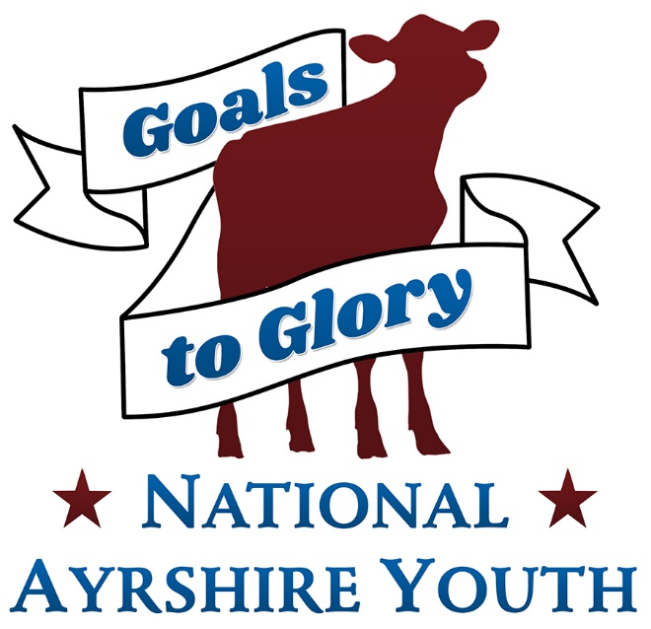
Poster and Print Ready Ad Contest!

Rules

1. All entrants must be Junior Members of the Ayrshire Breeders’ Association.

2. There will be four age divisions. Ages are as of January 1st of contest year.
•Senior Division: 16-21 •Intermediate Division: 13-15 •Junior Division: 9-12 •Pre-Junior Division: 8 & under

3. Entries by individual junior members only, not group or team efforts.

4. Jr and Pre Junior are to make a poster Promoting the Ayrshire breed. Intermediates and Seniors are to design a Print Ready Ad promoting the Ayrshire Breed, the association, genetic leaders etc. the sky is the limit!

5. Entries are to be emailed to info@usayrshire.com

6. Entries are due by June 10th @ midnight!

7. The theme must be Ayrshire related.

8. Posters will be judged on content, originality and creativity. Ads will be judged on Originality, promotional content, use of space and educational Impact.

9. Awards will be presented in each division.

